School of Computer Science and Artificial Intelligence

Lab Assignment # 5.5

Program : B. Tech (CSE)
Specialization : AIML
Course Title : AI Assisted Coding Course Code: 23CS002PC304
Semester : VI
Academic Session : 2025-2026
Name of Student : Nitesh Kumar
Enrollment No. : 2303A52098 Batch No. : 33
Date : 23/01/26

Lab Objectives:
- To explore the ethical risks associated with AI-generated Week3 -
code.
- To recognize issues related to security, bias, transparency, and copyright.
- To reflect on the responsibilities of developers when using AI tools in software development.
- To promote awareness of best practices for responsible and ethical AI coding.

Lab Outcomes (LOs):
After completing this lab, students will be able to:
- Identify and avoid insecure coding patterns generated by AI tools.
- Detect and analyze potential bias or discriminatory logic in AI-generated outputs.
- Evaluate originality and licensing concerns in reused AI- generated code.
- Understand the importance of explainability and transparency in AI-assisted programming.
- Reflect on accountability and the human role in ethical AI coding.

Problem: Use AI to generate two solutions for checking prime numbers.
  - Naive approach
  - Optimized approach

Prompt Used (Zero-shot)
Generate Python code for two prime-checking methods and explain how the optimized version improves performance.

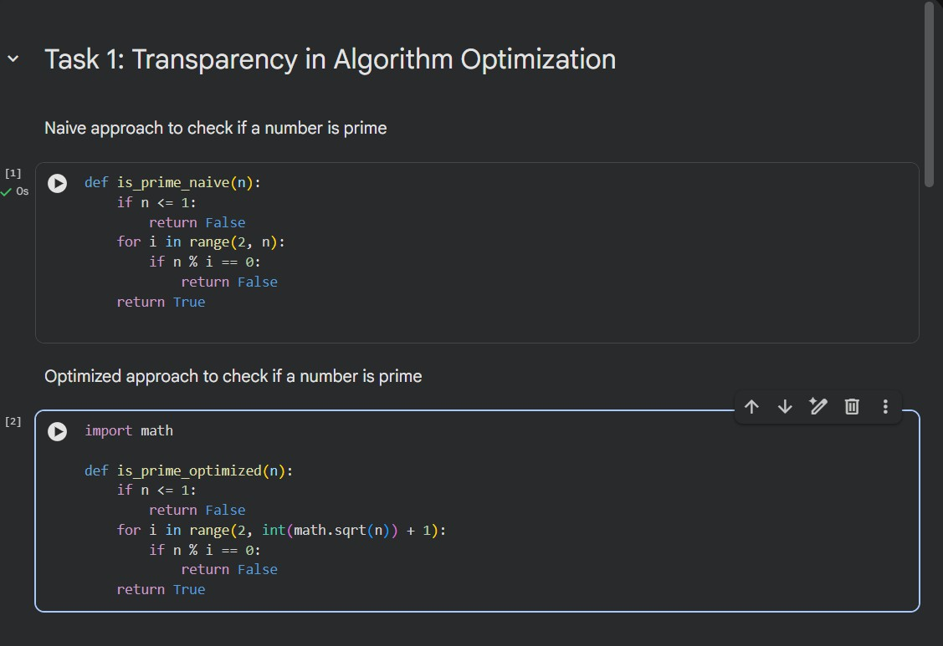
Python Code:
Explanation & Time Complexity

Naive Method
      - Checks divisibility from 2 to n-1
      - Time Complexity: O(n)
      - Inefficient for large numbers

Optimized Method
      - Checks divisibility only up to √n
      - Time Complexity: O(√n)
      - Faster because factors repeat after square roo

Problem: Generate a recursive Fibonacci function with clear explanations.

Prompt Used (One-shot)
- Ask AI to add clear comments explaining recursion.
- Ask AI to explain base cases and recursive calls

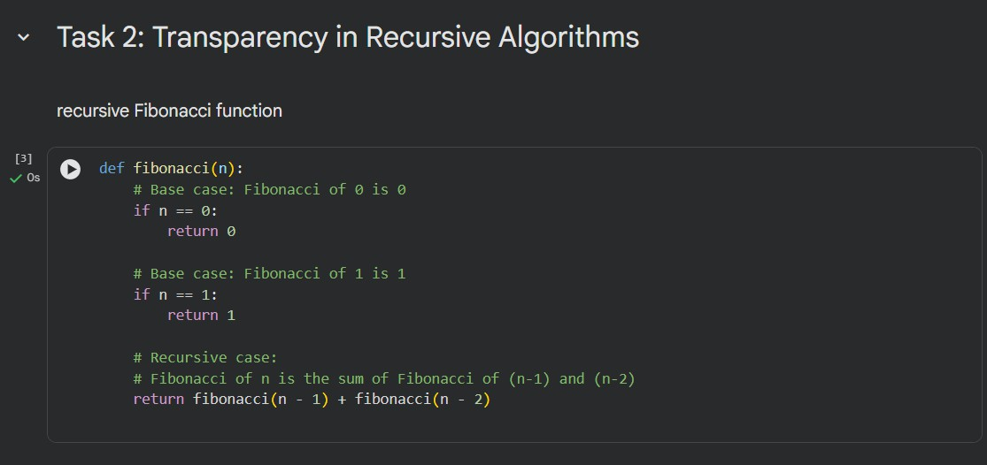
Python Code:
Explanation

Base Cases
    - fibonacci(0) returns 0
    - fibonacci(1) returns 1

Recursive Call
    - Function keeps calling itself with smaller values
    - Stops when base cases are reached

Execution Match
    - Each recursive call mirrors the explanation exactly
    - Ensures transparency and correctness

Problem: Use AI to generate a Python program that reads a file and processes data.

Prompt Used (Few-shot)
“Generate code with proper error handling and clear explanations for each exception.”

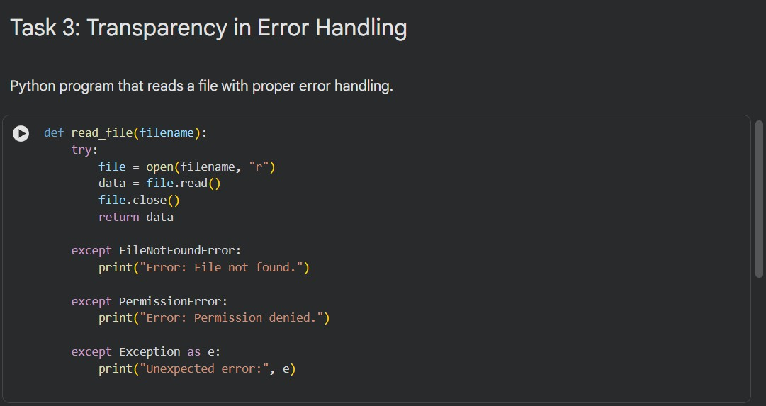
Python Code:
Explanation of Exceptions:

FileNotFoundError
    - Occurs when the file does not exist

PermissionError
    - Occurs when access rights are insufficient

Generic Exception
    - Catches unexpected runtime errors
Each explanation directly corresponds to actual Python runtime behavior, ensuring transparency.

Problem: Use AI to generate a Python program that reads a file and processes data.

Prompt :
Check whether the AI uses secure password handling practices.

Initial AI-Generated Issue (Security Flaws)
  - Passwords stored in plain text
  - No hashing
  - Weak input validation

Security Risks
  - Data breaches
  - Password reuse attacks
  - Unauthorized access
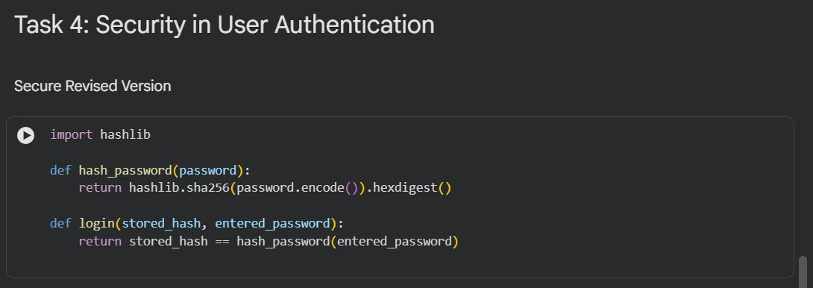

Best Practices for Secure Authentication
  - Always hash passwords (never store plain text)
  - Use strong hashing algorithms (bcrypt, SHA-256, etc.)
  - Validate user inputs
  - Implement rate limiting and authentication checks

Task Description – 5: Privacy in Data Logging
Problem: Determine the minimum of three numbers without using min().

Prompt Used : Examine whether sensitive data is logged unnecessarily or insecurely.

Original AI Logging Risks
  - Logs username, IP address, timestamp
  - IP addresses are sensitive personal data
  - Logs stored without masking or protection

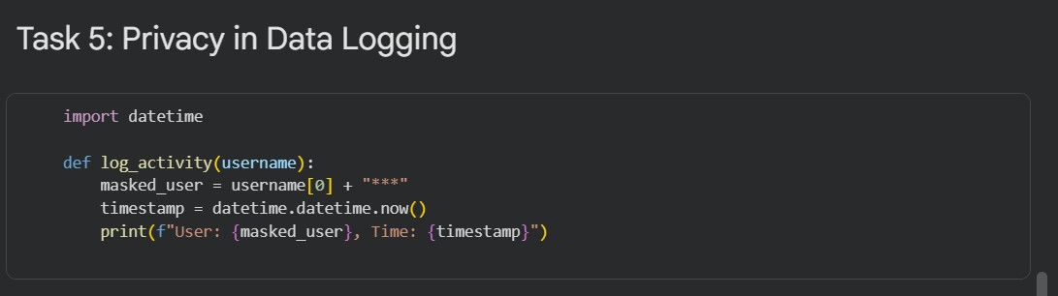
Python Code:

Privacy-Aware Logging Principles
  - Log only necessary information
  - Mask or anonymize personal data
  - Avoid storing IP addresses unless required
  - Protect log files from unauthorized access

Conclusion
This lab highlights that AI-generated code is not automatically ethical or secure. Developers are responsible for:
  - Reviewing AI outputs
  - Ensuring transparency and correctness
  - Preventing security and privacy violations
  - Maintaining accountability for deployed code
Ethical AI coding requires human judgment, not blind trust in AI tools.

